1. In order to complete this assignment, I utilized Amazon sagemaker. First I set up AWS EMR environment. This helped me create the ec2 instances and security groups needed to communicate with each other.

EC2 Instances & Security Groups:

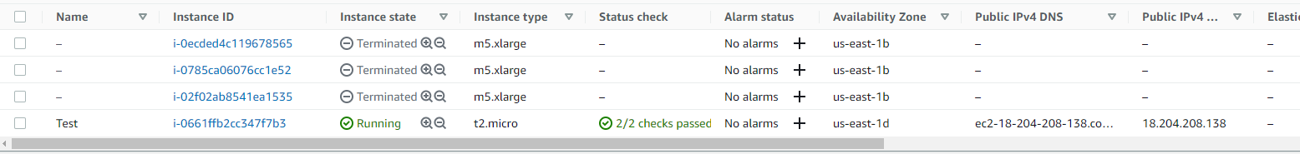

1. Next, I created a sagemaker notebook which enabled me to write my python code in Jupyter notebook to train the model. I also created an S3 bucket to store the training and validation set.

1. Once this was set up, I was able to write out my code to train my ML model. For this assignment, I decided to go with a random forest model.

1. Next I set up a docker container on AWS to run the task of making the prediction. It is linked to an ECR.

ECR Configs:

